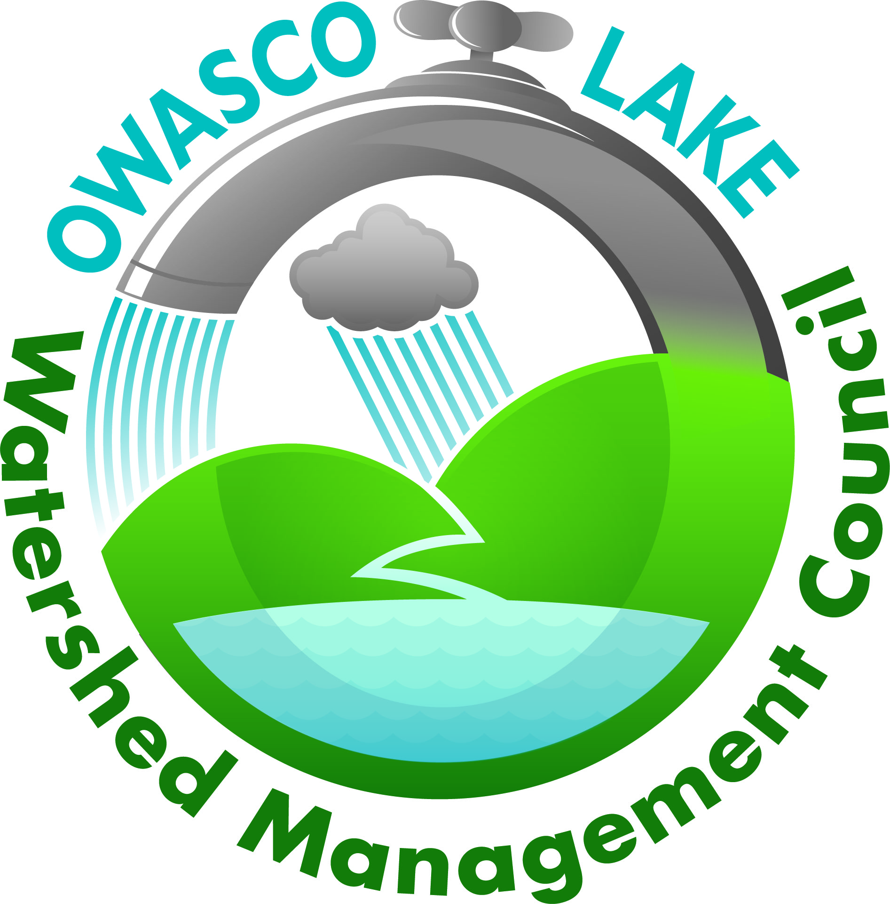
Owasco Lake Watershed Management Council
November 19, 2019, 10:00am – Agenda

Meeting of the Directors

Owasco - Ed Wagner, Cayuga County- Aileen McNabb -Coleman, City of Auburn - Debby McCormick
Niles – Joan Jayne, Locke - Mary Alice Stetz, Scipio - Leslie Baxter, Fleming - Don Oltz,
Moravia – Terry Baxter, Village of Moravia – Gary Mulvaney, Village of Groton – Nancy Niswender, Town of Summerhill – Susan Stout
Council Executive Director- Adam Effler

  - Approval of the Agenda
  - Approval of Minutes from the October 15, 2019 meeting
  - Public to be Heard
  - Board of Directors/Municipality Representatives Feedback
  - Director’s Summary- Adam Effler
  - Treasurer’s Report – Joan Jayne
  - HABs, associated features and drivers, indications from the NYS HABs Survey and the CSLAP- Dr. David Matthews, Executive Director of the Upstate Freshwater Institute (UFI)
  - Innovative Phosphorus Removal (from manure) Technologies, Project Update- Crystal Creek Organics, Bill Jones
  - NYSDEC Hub Updates- Tony Prestiagacomo
  - Research Updates- John Halfman
  - Update on Rules and Regs Revisions – Steve Lynch
  - TNC updates- Olivia Green
  - Watershed Inspection Monthly Report – Andrew Snell and Kaitlyn Shanahan
  - Lake Level Report – John West
  - Communications
  - Issues of Concern
  - Schedule Next Meeting (3rd Tuesday of December is the 17th)

2019 OLWMC Goals

- Increase participation of additional towns on the Council.
- Community Outreach
  - Increase awareness of the boundaries of the watershed through signage.
  - Mobilize an outreach campaign for eventual rollout of Rules and Regulations
    - Plan distribution methods for supportive materials for guidance for watershed programs and lines of supportive funding.
  - We are working towards development of a watershed specific farmer’s advisory committee
    - Growing membership
    - Determine meeting times and location

- Continue to look for funding opportunities.
  - Advance funding support for project initiatives through collaboration for funding and partnership among agencies
  - Adaptive strategies for the priorities list based on funding availability
  - Seeking watershed support as a line item on the NYS Environmental Protection Fund (EPF)
- Work with the Towns’ elected officials and highway superintendents and Cayuga County Soil and Water Conservation District to improve ditching practices.
    - Improved communication between highway departments and CCSWCD. Developing prioritized action plan- future priority locations for restoration to be determined by monitoring results.
- Participate in the on-going NYSDEC harmful algal bloom monitoring and surveillance program, the purpose of which is to identify priority areas for health and safety and ultimately develop mitigation strategies for HABs.
    - OWLA- 2019 sampling plan
        - OWLA/NYSDEC/OLWMC collaboration essential
- Continue to revise the Owasco Watershed Rules and Regulations, a working document
    - Updates based on recent public meetings and feedback, as well as the new naming convention for the watershed inspection and protection division
    - Stakeholder meeting feedback and local governmental review
- Continue to move forward with support for oversight and guidance for the Watershed Inspection Division
  - Administrative needs for watershed rules and regulations waivers process
    - Staff growth and funding
  - Implementable and comprehensive inspections
    - Staff growth and funding
  - Extension of the division for improved outreach and assistance for funding and guidance for stakeholders
    - Staff growth and funding
- Continue monitoring the lake to assess water quality.
  - Transferrable datasets between multiple groups, scientists and planners/managers
  - Work with the DEC Finger Lakes Hub in reducing nutrient loading and HABs.
    - Transitioning from 9E plan information and priority sites or ‘hot spots’ to target watershed project implementation
      - Presentation of priority information for managers to support priority project implementation

